Name: Class: Mark:

1. An automatic door to an office building makes use of a microwave sensor to detect when people are near the door.
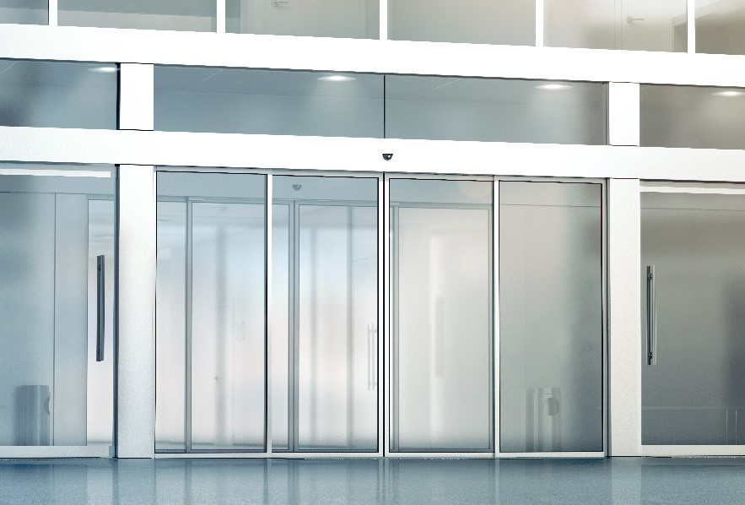

(a) State two other sensors. [2]

(b) State two other components that are needed for this automated system to work. [2]

2. An ice cream factory makes use of an automated system to fill ice cream tubs.
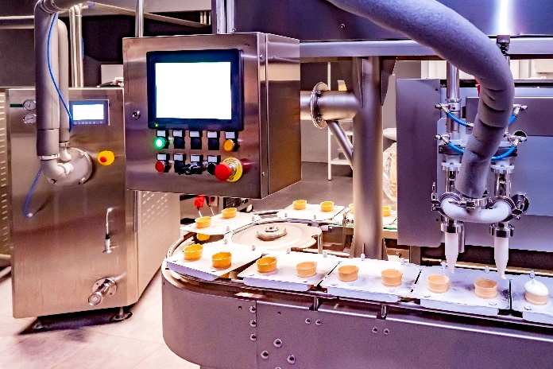
(a) Describe how this automated system works. [4]

(b) Suggest two advantages of using an automated system in the ice cream factory. [2]
1:

2:

(c) Suggest two disadvantages of using an automated system in the ice cream factory. [2]
1:

2:

[Total 12 marks]

